|  |
| --- |
| Logbook for ISD |
| Yeva Dyomina 21364018 |
|  |
|  |

Logbook for ISD

Yeva Dyomina 21364018

Contents

Introduction 2

Week 1 3

Exercises 1 3

Exercises 2 3

Exercises … 3

Week 2 4

Exercises 1 4

Exercises 2 4

Exercises … 4

Week 3 5

Exercises 1 5

Exercises 2 5

Exercises … 5

Week…13 6

Exercises 1 6

Exercises 2 6

Exercises … 6

# Introduction

A brief introduction to what you have done within the module and how your experience was with the exercises and the overall module. Probably up to half a page.

# Week 1

Some overview of the topics covered by the lecture and the exercises. Not too much, may be a paragraph.

## Exercise 1

## What is a code repository (often also called version control system) used for?

## Answer:

A code repository is a file archive and web hosting facility where you can keep a large amount of source code, for software or for web pages, either publicly or privately. They are often used by open-source software projects and other multi-developer projects to handle various versions. They also help developers submit patches of code in an organized fashion.

## Exercise 2

## Provide the exercises description and your answers. Where applicable use source code excerpts, explanations of these, represent your results, for example by showing screenshots of your program and, where applicable, display the use of your code repository (github) either by screenshots or by providing log data from your code repository.

## Answer:

The benefits of using a code repository: it makes it easier for open-source projects to manage their projects, to get an excellent documentation  and allows your work to get out there in front of the public.

## Exercise 3

## Describe the different “layers” of Software that exist on a typical computer and explain why there are different layers of software.

## Answer:

Application Software is one of the Software layers. Application Software are the programs that make a computer useful for everyday tasks and programs that people normally spend most of their time running on their computers. One of the examples is Microsoft Word - word processing program that allows you to create, edit and print documents with your computer. This is one of the programs that every computer has.

## Exercise 4

## Describe what an algorithm is and explain why it is a useful “tool” to translate from a human level problem (we can think of) to a computer program.

## Answer:

Algorithm is an unambiguous specification of how to solve a class of problems. Algorithms can perform calculation, data processing and automated reasoning tasks. They are important because they solve a lot of problems, for example The Internet. The Internet in it's entirety is composed of so many algorithms, which make it possible for people like you and me to have the knowledge of the universe at the click of a button.

# Week 2

Some overview of the topics covered by the lecture and the exercises. Not too much, may be a paragraph.

## Exercise 1

## Write an algorithm that describes how to make scrambled eggs, try to use control words, like IF, WHEN, UNTIL, WHILE, WAIT, AND, OR.

## Answer:

1. Whip eggs with mixer.
2. Add milk, salt AND spices.
3. Whip it again.
4. Heat the pan UNTIL it’s hot enough.
5. IF the pan is hot enough, grease it with oil.
6. WHEN the pan is ready, add egg mass.
7. Cook on the medium fire FOR 2-3 minutes.
8. WHILE it’s cooking prepare the dish.
9. WHEN scrambled eggs are ready, put them onto the dish OR wait UNTIL it cools down.

## Exercise 2

## Is Idle (the Python language shell) an Interpreter or an Compiler or both? Explain your answer.

## Answer:

Idle, the Python language shell, is an Interpreter, because it both translates and executes the instructions in a high-level language program.

## Exercise 3

## Write a command in the Idle shell that says “Hello world”

Answer: 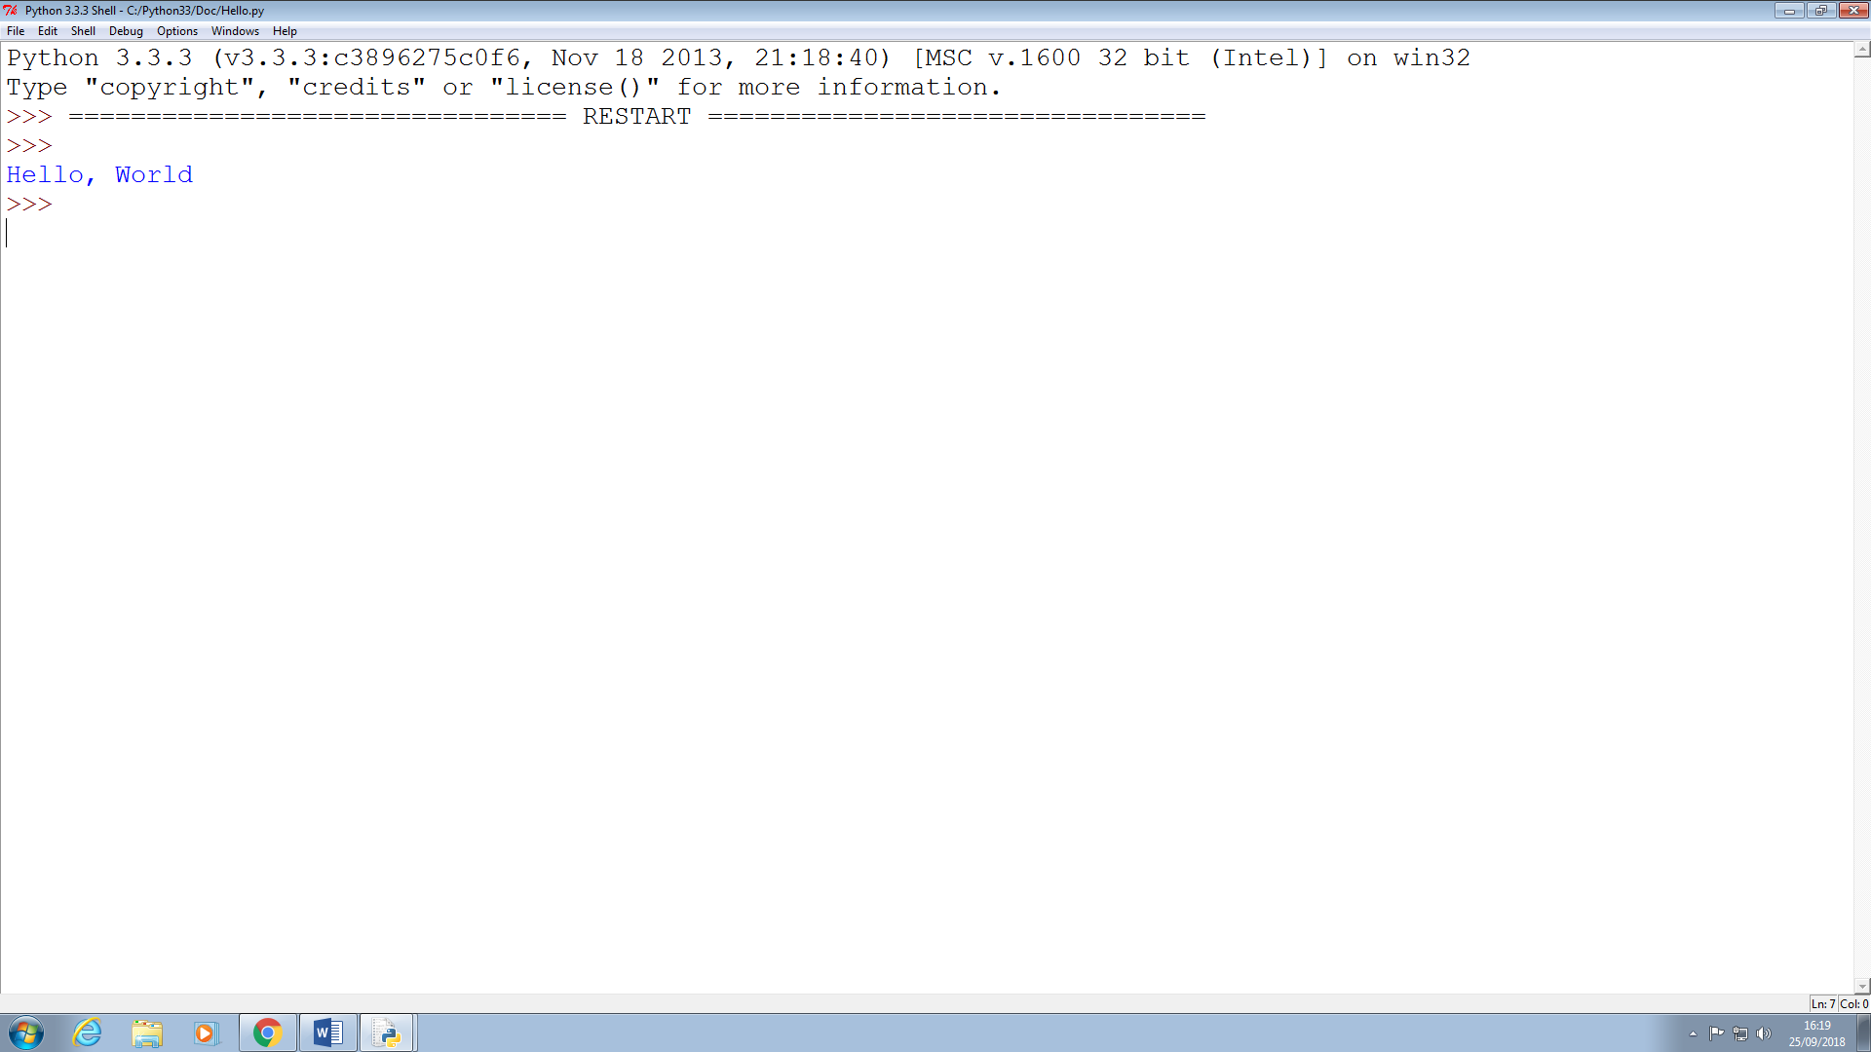

## Exercise 4

## Write a program that produces the following output:

## Hello World

## I am in my ISD class right now

Answer: 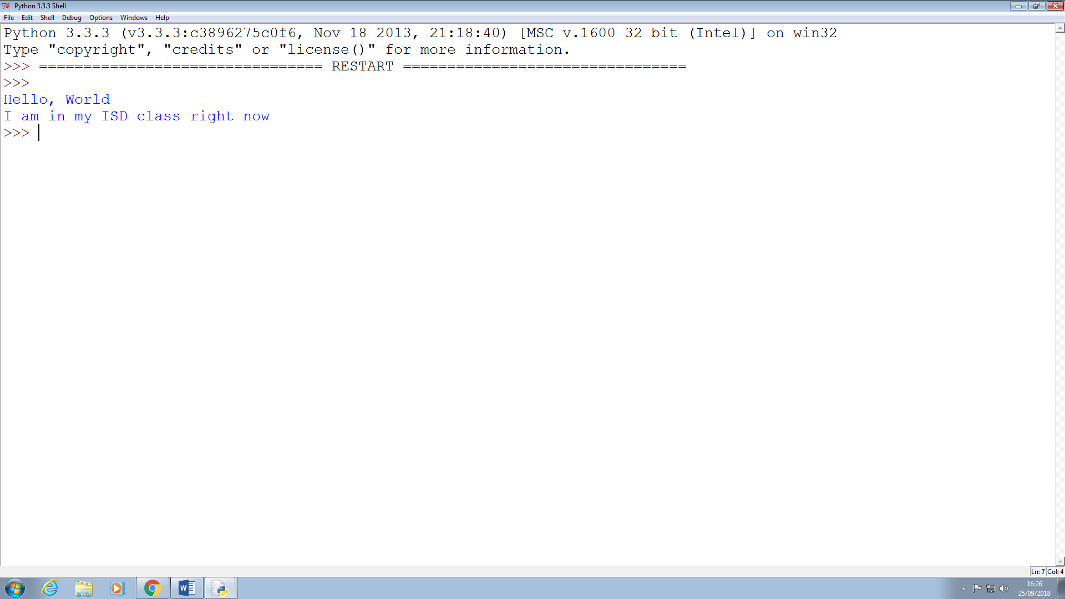

## Exercise 5

## Write a program that asks the user for his/her name and produces an output like:

## Hi there, what is your name?

## >User input to be read<

## Hello “User name”

## How are you?

Answer: 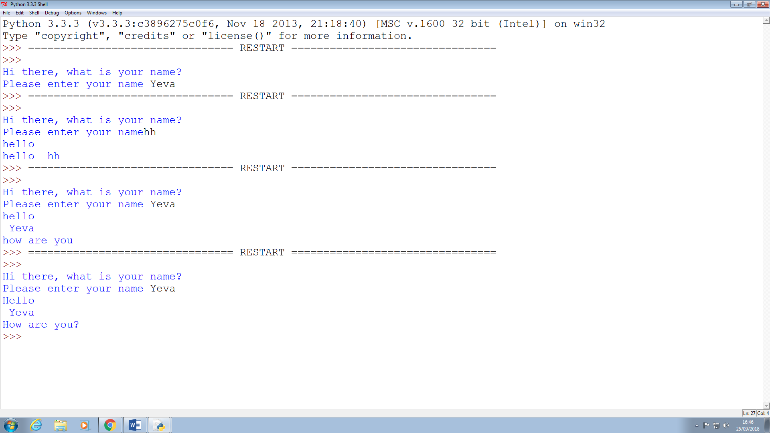

# Week 3

Some overview of the topics covered by the lecture and the exercises. Not too much, may be a paragraph.

## Exercise 1

## Write a program that asks for two numbers (Python has all the basic mathematical functions in place, like +,- etc.), adds them up and displays the result.

Answer: 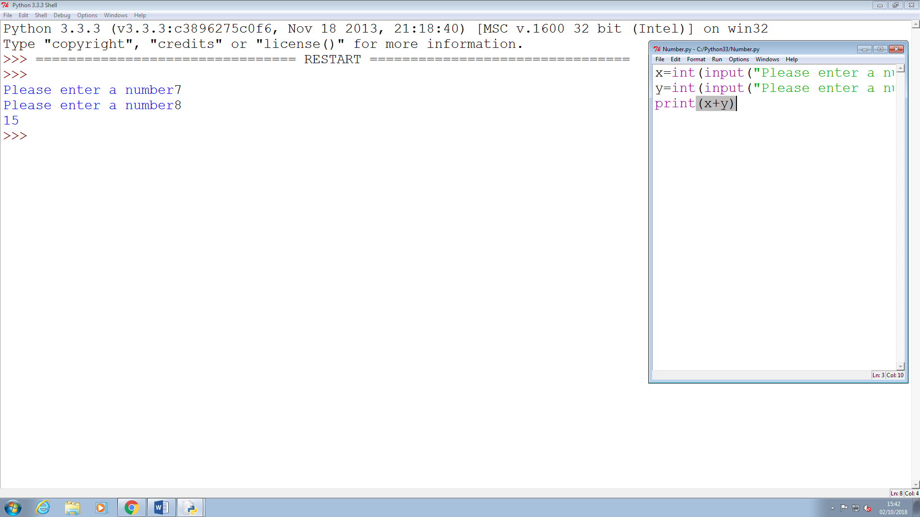

## Exercises 2

## Answer the questions by implementing the code and run it

### What will the output be from the following code?

num = 4

num*=2

num1=num+2

num1+=3

print(num1)

Answer: 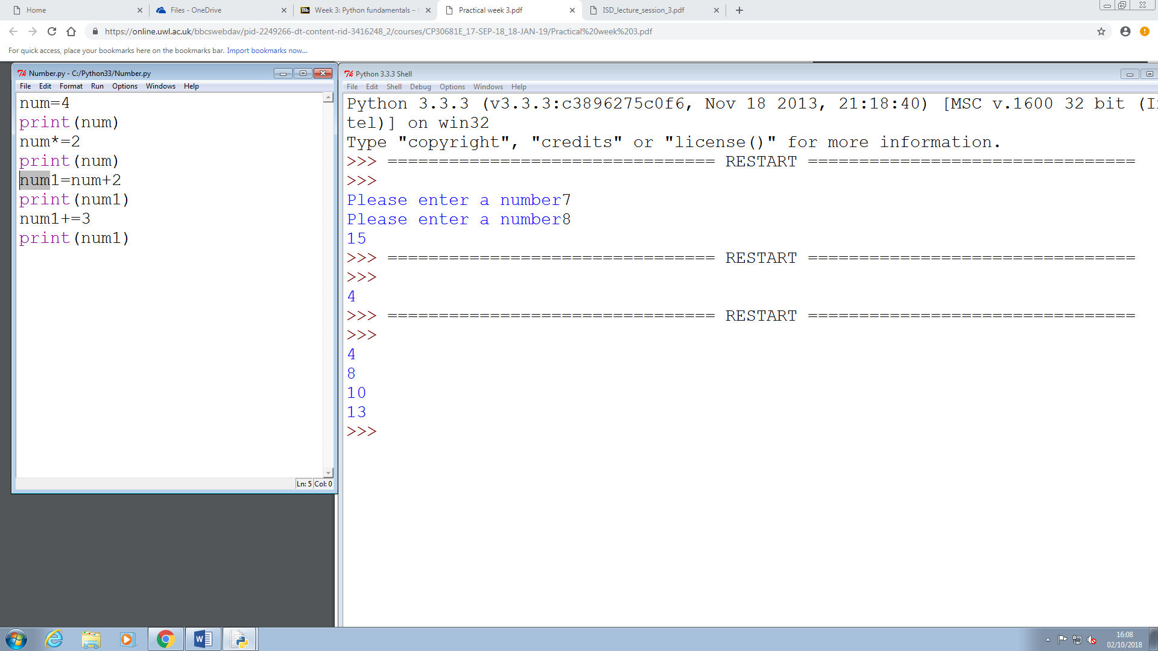

### What do the following lines of code output? Why do they give a different answer?

print(2 / 3)

print(2 // 3)

Answer: 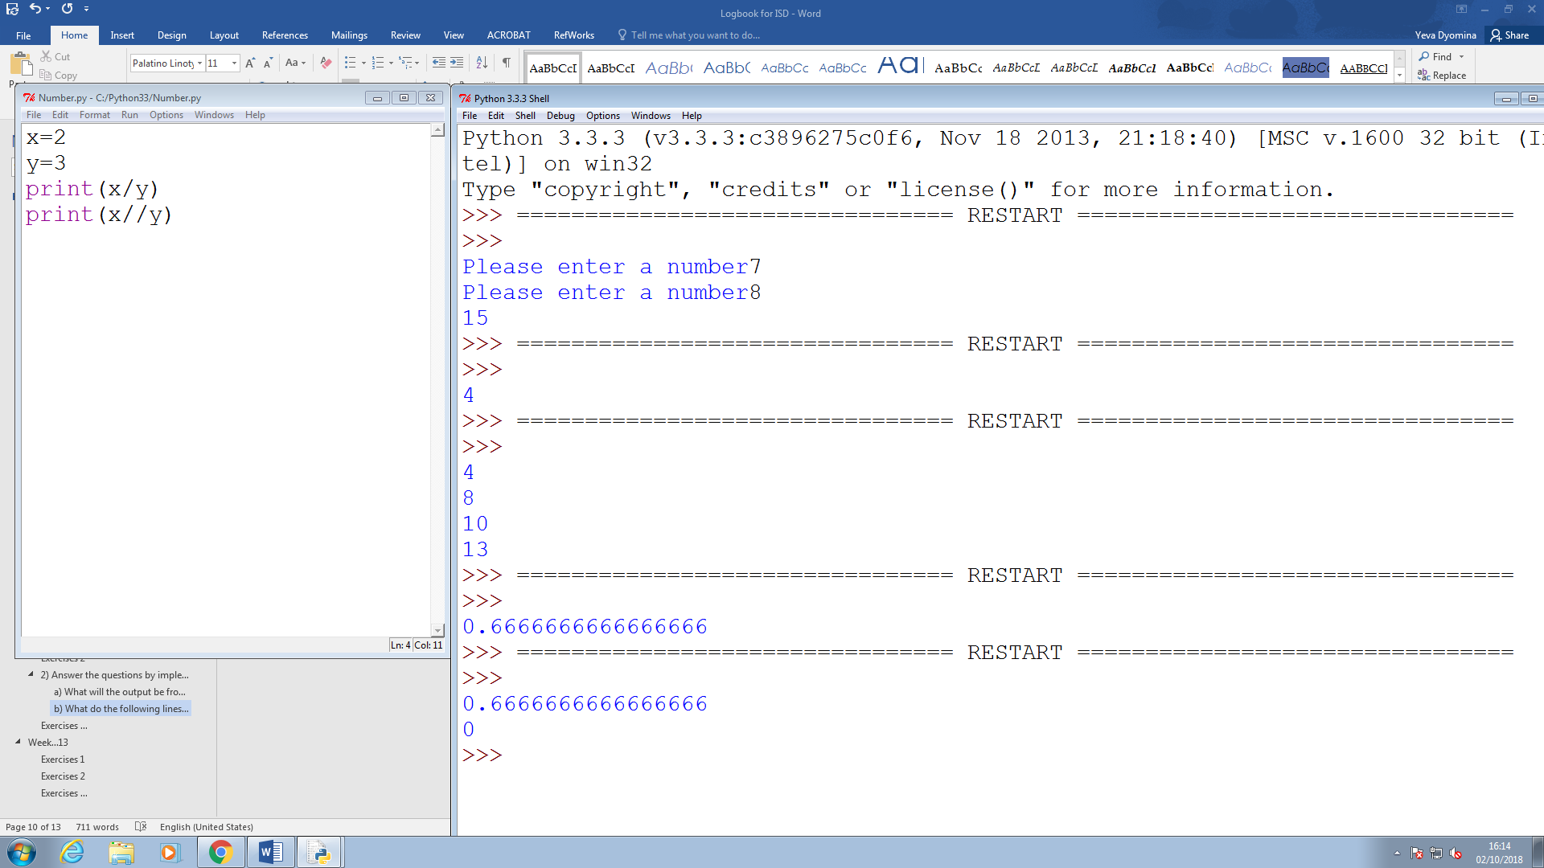

## 

## Exercise 3

## All of the variable names below can be used. But which of these is the better variable name to use?

### A a Area AREA area areaOfRectangle AreaOfRectangle

## Answer:

areaOfRectangle

## Exercise 4

## Which of these variables names are not allowed in Python? (More than one might be wrong.)

### apple APPLE Apple2 1Apple account number account_number account.number accountNumber fred Fred return return_value 5Return GreatBigVariable greatBigVariable great_big_variable great.big.variable

## Answer:

1Apple

# Week 4

Some overview of the topics covered by the lecture and the exercises. Not too much, may be a paragraph.

## Exercise 1

## Explain the mistake in the following code:

## radius = input("Radius:")

## x = 3.14

## pi = x

## area = pi * radius ** 2

## Answer:

Because the value for radius will be read as a string.

## Exercise 2

## Explain the mistake in the following code:

## x = 4

## y = 5

## a = 3(x + y)

## Answer:

Line 3 should be a = 3 * (x + y). It has to contain the * to multiply, otherwise it won't work.

## Exercise 3

## Explain the mistake in the following code:

## radius = input(float("Enter the radius:"))

## Answer:

Should be radius = float(input("Enter the radius:"))  
Float should come first, then input. Example: float(input())

## Exercise 4

## Why does this code not calculate the average?

## print(3 + 4 + 5 / 3)

## Answer:

Because the program first divides 5 and that summarizes it with other integers. We should take 3+4+5 in individual brackets. Example: print((3+4+5)/3)

## Exercise 5

## Consider the following code:

## x = 19.93

## y = 20.00

## z = y – x

## print(z)

## The output is 0.0700000000028

## Why is that so? Improve the code so that the output is to two decimal places.

## Answer:

Because the absence of fractions in binary creates the need for a special math module to perform the massive amount of work needed to compute in decimal fractions or very small numbers.

It should look like that:

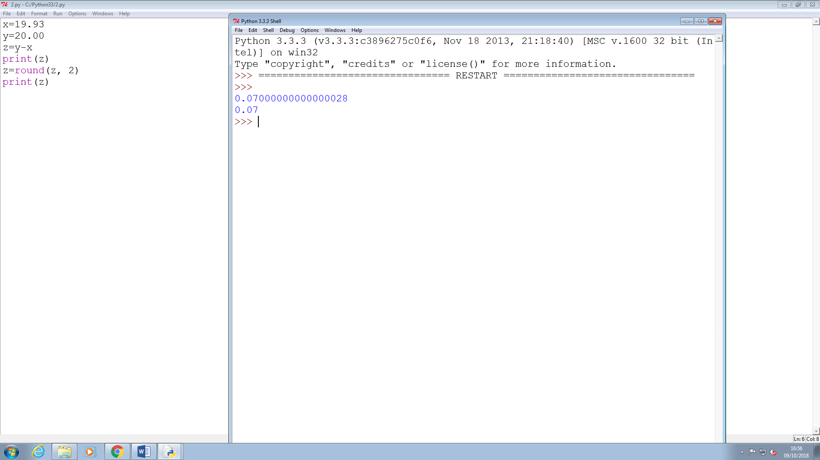

Example description of an exercise:

